A connectome-constrained Drosophila neural network learns to act as a Maxwell demon in a simulated particle system
Working title as specified. Final wording to be locked against the full E1–E11 demonstration set (see Title note in Methods).
Authors: [corresponding author* and coauthors — to complete] (* corresponding author)

Abstract
Background: Maxwell's demon asks whether measurement, memory and control can sort a gas against entropy; biological nervous systems are information-processing controllers, and the connectome of adult Drosophila provides a measured substrate for such control. What was constructed: we use a closed-loop simulation — a two-temperature particle chamber with a heat jet, a demon-gated aperture, and an embodied fly — in which the FlyWire FAFB v783 connectome (106,765 neurons, ~5.6 × 10^5 signed edges) receives observations of the particle environment, produces spiking motor actions that gate particle transport, and undergoes reward-dependent (dopamine-gated) plasticity. What was tested: the project's seeded experimental programme E1–E11 (classical reference demon, ANN, Drosophila-inspired, connectome and shuffled-connectome controllers; causal, information-limit and physics-regime controls; pressure-valve, Smoluchowski and Feynman-ratchet apparatus), plus a live Interactive-Lab condition matrix crossing three demon drivers (fly brain, random, scripted human) with two fly actions (help = plasticity sign flipped; obey = learn the demon's task), with 1-Hz telemetry, brain firing and chemistry maps, and video recordings. Main measurements: temperature sorting (ΔT), crossing ledgers, gate actions, fly locomotion and motor rate, neural firing, synaptic changes, reward and dopamine, and full energy/information accounting. Main finding: the connectome network genuinely learns gate policy — flipping the dopamine sign halves demon agreement (60.6% → 30.9%) — yet sortedness is set by the physics (jet power, noise), no neural condition approaches the reference demon's selectivity, and the thermodynamic ledger remains unpaid: the system teaches and tests demon-like control, but sorting is jet-subsidized, not information-driven.

1. Introduction

1.1 Maxwell's demon as an information-processing problem
Maxwell's 1867 thought experiment separates fast from slow molecules with a gated, selective 'demon', seemingly reversing entropy. Szilard, Landauer and Bennett resolved the paradox: measurement, memory and erasure carry thermodynamic bills that restore the second law1–3. Experimental demons confirm the principle4,5. Throughout, we treat the demon as an information-processing and control problem; we do not claim our simulation is physically equivalent to the original thermodynamic demon.

1.2 Biological neural systems as controllers
A nervous system senses, processes, acts, receives consequences and modifies future behaviour — exactly the loop a demon performs (measure → decide → gate → profit/pay). This is the conceptual bridge between neural control and the demon task.

1.3 Why Drosophila?
Drosophila offers the most complete measured wiring diagram of any animal (the FlyWire FAFB connectome6,7), compact and well-characterized learning circuitry (mushroom body; dopamine-gated plasticity9), and a body plan that can be simulated with physics (NeuroMechFly8). Connectome constraint makes the computation biological, not merely biologically inspired.

1.4 The central question
Can a connectome-constrained Drosophila neural network learn to use sensory information to control particle transport through a gate in a simulated Maxwell-demon environment? Secondary questions: can it learn the gate policy; does learning alter neural activity; does plasticity alter future behaviour; how does it compare with a reference demon; how does performance change under different physical conditions?

1.5 What we constructed
A complete closed-loop system: particle environment → observation → connectome-constrained spiking network → motor output → gate → particle outcomes → reward → dopamine → synaptic plasticity → future behaviour (Fig. 2), embedded in a live 3D apparatus (Fig. 1) with an Interactive Lab for condition control, plus the seeded headless programme E1–E11 for controlled inference.

2. The simulated Maxwell-demon system

2.1 Physical apparatus (annotated)
Figure 1 shows the apparatus with every structure annotated: two gas chambers separated by a wall with a controllable aperture (the demon's door, aperture 64 units at default); a heat jet that injects fast particles (power 0.55, aim 0.5, auto-puff every 3.5 s) and a cool sink that withdraws energy; speed-coded particles whose crossings are counted good (hot→cold) or bad (cold→hot); the embodied fly sharing the same simulator; and the demon driver. The Maxwell-demon condition: the driver observes local temperature/density around the door and opens the gate preferentially for fast particles moving hot→cold and slow particles moving cold→hot, building ΔT = T_hot − T_cold against the gradient that the jet continually erases.
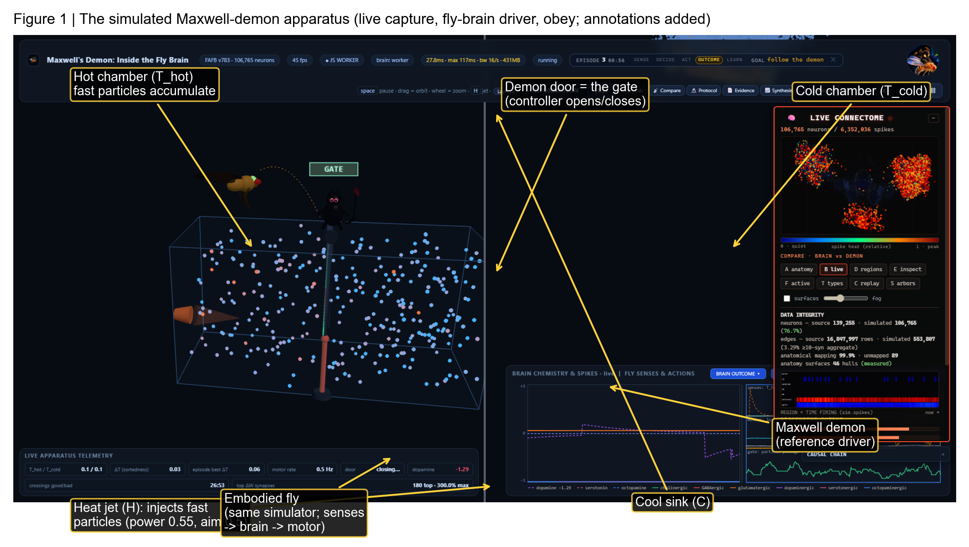
Figure 1 | The simulated Maxwell-demon apparatus. Live capture of the Interactive Lab with the fly-brain driver (obey), annotated: hot and cold chambers, the demon door (gate), the heat jet and cool sink, the embodied fly, and the demon reference driver. The Maxwell-demon condition is the selective gating of particle crossings to build ΔT against the jet-driven gradient. Annotations added for publication; underlying screenshot is the app's own render.

2.2 Particle/gas environment
N = 320 point particles (default; range 120–600) move with velocity Verlet integration at dt = 1/60 s inside reflecting walls; noise is a per-step velocity diffusion (default 0.12); the door is a binary gate with adjustable aperture; temperature classes are defined by speed relative to the two reservoirs. Crossings, per-side mean speeds and the resulting ΔT are computed continuously; an energy ledger converts simulation work to joules (sim-to-Joule factor 10⁻²¹, T_env = 300 K, k_B = 1.38 × 10⁻²³ J/K) and prices memory in Landauer bits (Methods).

2.3 Maxwell-demon controller
The reference (classical) demon senses approach speed and direction at the door and applies an adaptive threshold policy: open only for demon-favourable crossings. A successful sorting event is a good crossing that raises ΔT; the measured quantity is ΔT (and its trend), the crossing ledger, and the full energy/information budget (work in, extractable work out, Landauer bill, bits used vs bits needed). This makes 'Maxwell demon' operational rather than metaphorical: every claim reduces to these measurements.

3. Connectome-constrained Drosophila neural network

3.1 Connectome architecture
The controller is built from the FlyWire FAFB v783 proofread connectome (female adult brain; 106,765 neurons in the app's renderer, 400 bundles, 564,030 mapped edges; circuit file sha256 0eb64ba4…98671)6,7. Edges carry signed weights from predicted neurotransmitter classes; sensory channels map onto antennal/visual inputs and the motor pool drives action readout. The full derivation (dataset, preprocessing, mapping) is in Methods and reproduces the published pipeline.

3.2 Neural dynamics
Neurons are leaky-integrator (LIF) units; spikes propagate over the signed connectome (CSR-style propagation); synaptic dynamics include dopamine-gated three-factor plasticity with eligibility traces (0.90/0.45, 0.985/0.35, 0.9995/0.20); motor output is a policy readout on the motor pool. The same brain passes all nine causal gates of the project's closed-loop MuJoCo embodiment (240 steps, seed 11) through two independent entry points10.

3.3 Observation → neural activity → action
The central computational chain is: environment → observation (temperature, density, jet, door channels) → connectome → spiking activity → motor output → gate → particle outcome (Fig. 2a), rendered live on anatomy (Fig. 2b). This figure is the paper's architecture map; nothing outside this loop influences the gate.
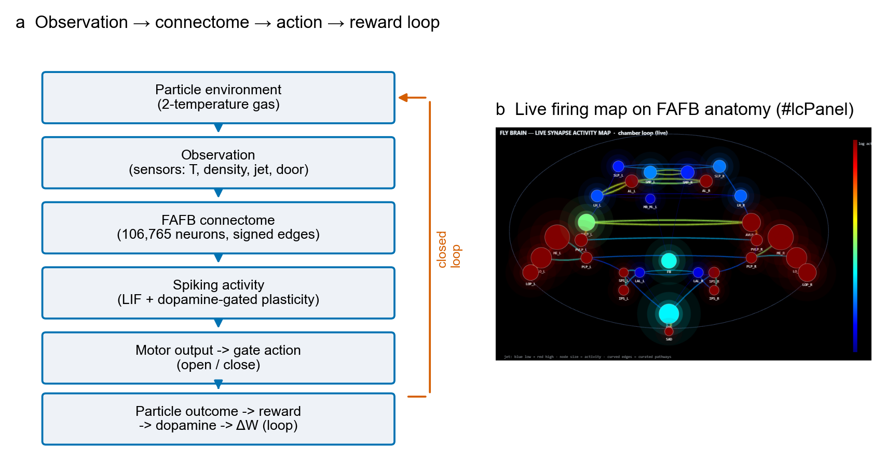
Figure 2 | Computational architecture of the closed loop. a, The chain: particle environment → observation → FAFB connectome (106,765 neurons, signed edges) → spiking activity with dopamine-gated plasticity → motor output → gate → particle outcome → reward → dopamine → ΔW, closing the loop (orange). b, The app's live firing map (#lcPanel): spiking activity rendered on the FAFB anatomy during a run. Model activity — not a biological recording.

4. Learning and plasticity

4.1 Reward
Reward is delivered by particle outcomes: demon-favourable crossings (and, in the apparatus tasks, work-rate terms) produce positive reward; demon-unfavourable outcomes produce negative reward. In help mode the sign is flipped programmatically: the same crossing that rewards the demon's task now penalizes the fly's sort-policy — a causal test of the learning rule itself.

4.2 Dopamine
Reward is conveyed by a dopamine signal (UI scale 1.5) with the timing of the eliciting event; dopamine is displayed and logged live (Fig. 4b chemistry panel; 1-Hz telemetry). Help mode produces negative dopamine excursions where obey produces positive ones — the sign flip is visible in the neuromodulator trace, not only in behaviour.

4.3 Synaptic plasticity
Dopamine gates three-factor plasticity: ΔW follows eligibility traces on the signed connectome, so reward → dopamine → ΔW → future gate policy. Top-synapse updates are shown live ('top ΔW synapses') and logged; this makes 'learns' experimentally testable: policy, dopamine sign and ΔW must co-vary.

4.4 Learning parameters
Learning rate 0.004; dopamine scale 1.5; exploration 0.45; plasticity sign ±1 (help flips it); episodes are 60-s interactive windows (headless programme: 12–24 episodes × 10–24 trials per condition); seeds follow 1 + idx·101 with pre-registered seed schemes (Methods). The Interactive-Lab session reported here is n = 1 per condition; the controlled programme supplies the multi-seed statistics.

5. Experimental design: E1–E11
The E1–E11 definitions below are recovered verbatim from the executable manifests (experiments/e1.json–e11.json; source of truth: experiment_worker.js EXPERIMENTS + experiment_core.js constants) — not invented. Each experiment is seeded with train/test splits; the seed is the independent replicate. Figure 6 is the summary matrix; Table 1 (Section 6) adds the live Interactive-Lab condition matrix run for this paper.
- E1 · Classical Maxwell Demon — does an adaptive-threshold classical demon sort an ideal gas, and at what thermodynamic cost? (reference policy; defines ΔT, ledger, bits used/needed)
- E2 · Artificial Neural Demon — can a small learned ANN policy match the engineered demon on the same observations? (control: learning without biology)
- E3 · Drosophila-Inspired Network — does a PN→KC→MB-output LIF network with dopamine-gated plasticity learn the demon task? (control: biological architecture without the connectome)
- E4 · Connectome-Constrained (4A/4B/4C) — does real FAFB wiring beat restricted-pathway and shuffled controls? (manipulation: wiring; control: degree-preserving shuffle)
- E5 · Full Comparator Study — head-to-head classical vs ANN vs drosophila vs connectome vs shuffled connectome, one seeded run with CIs
- E6 · Jet-Closure Paradox — causal decomposition of ΔH: demon vs random vs never-gate with the jet running (is sorting jet-subsidized?)
- E7 · Generalization Sweep — does the learned policy transfer across density × noise regimes?
- E8 · Information-Limited Demons — the behavioural price of less measurement/memory (adaptive vs fixed threshold vs mem4)
- E9 · Pressure Demon — can the FAFB brain, as valve controller, build ΔP and net positive spring work against the Landauer bill?
- E10 · Smoluchowski Trapdoor — does a spring flap (passive or brain-gated) sort the gas? (expected: no; equilibrium wins)
- E11 · Feynman Ratchet & Pawl — does the ratchet extract work only while Th > Tc (nothing at equilibrium), brain-pawl included?
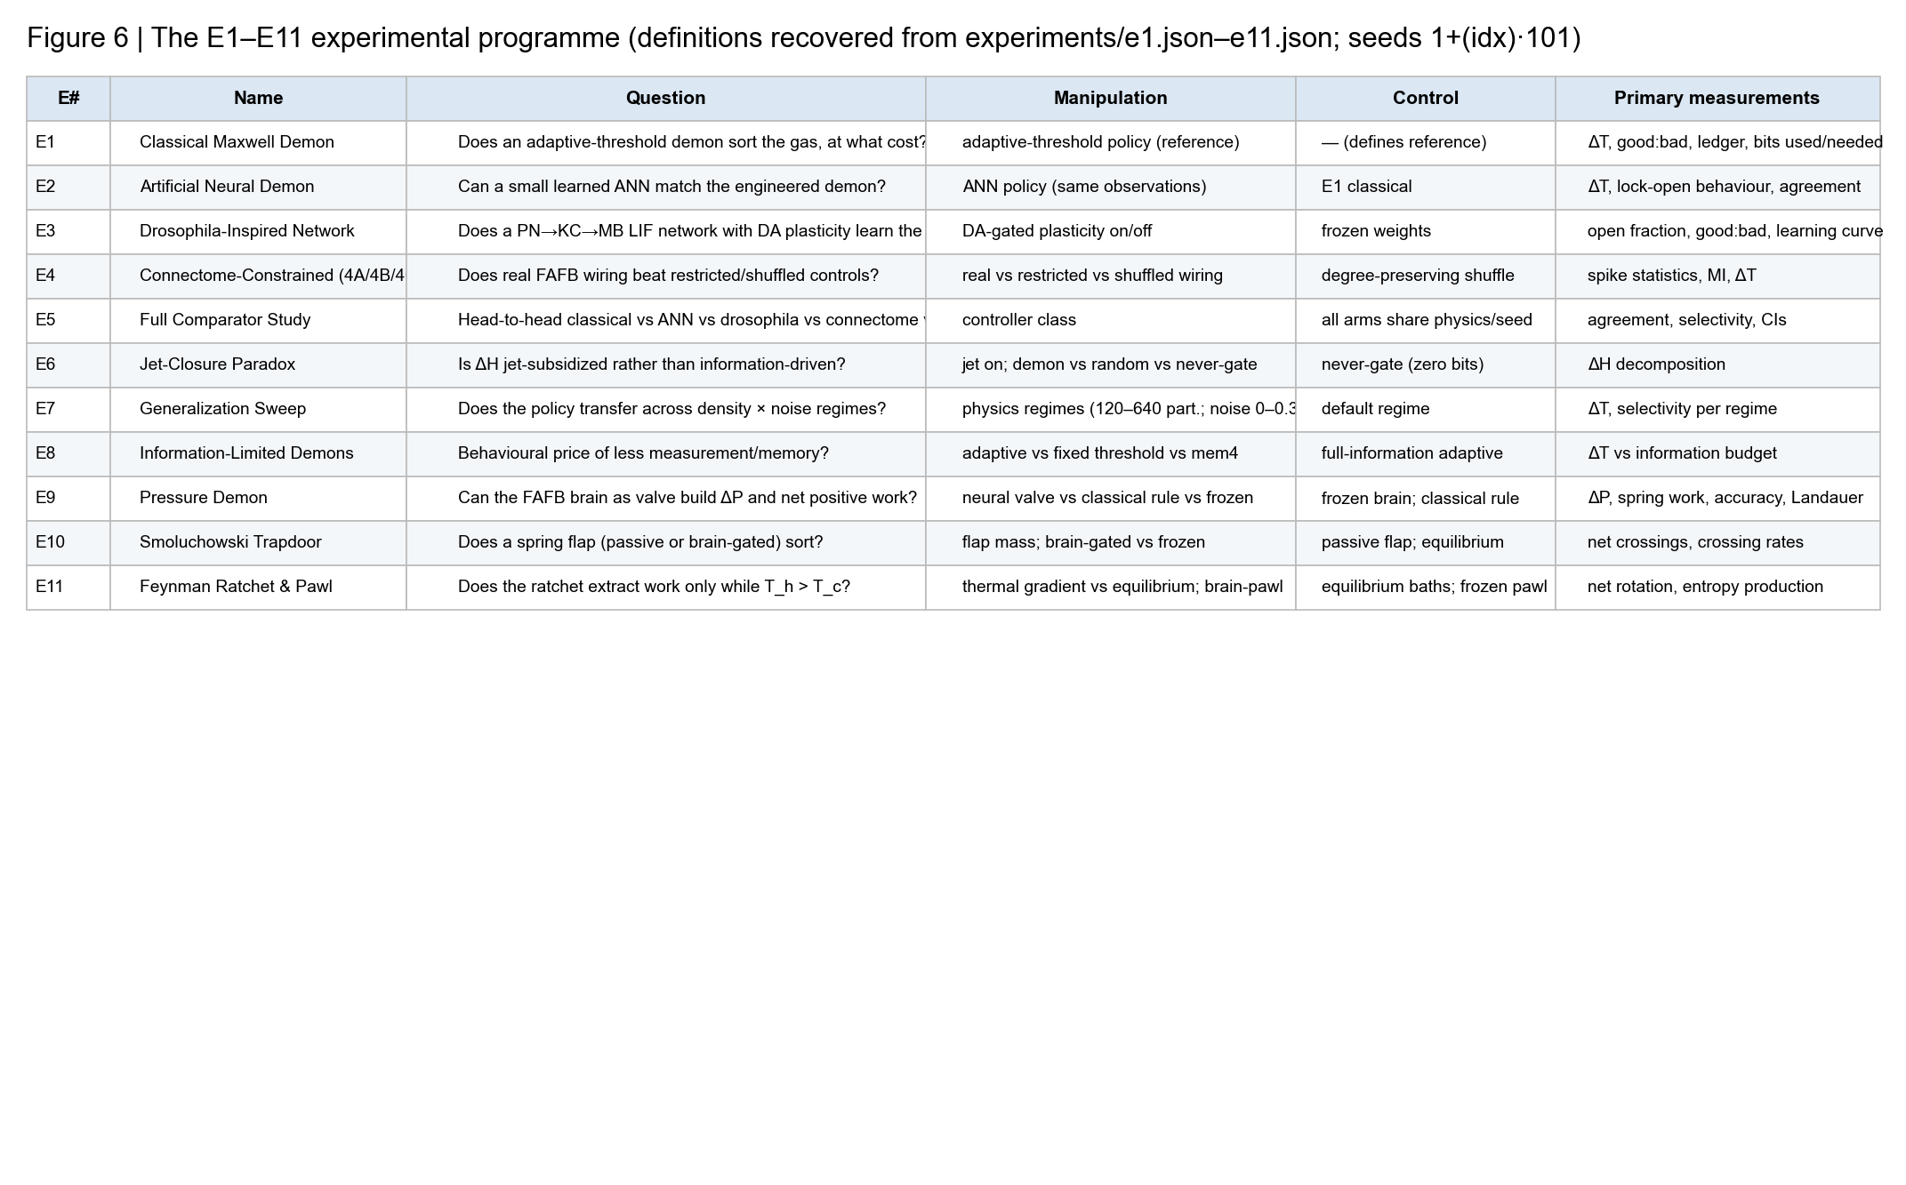
Figure 6 | The E1–E11 experimental programme at a glance. For each experiment: question, manipulation, control and primary measurements, recovered from the executable manifests (experiments/e1.json–e11.json). Seeds are the independent replicates (env seed = 1 + idx·101; brain draws and readout RNGs pre-registered per manifest). The Interactive-Lab condition matrix of Table 1 operationalizes E1/E3/E5-style questions in the live environment.

6. Experimental measurements

6.1 Physical measurements
Per-side particle distributions and speeds, energy and temperature, equilibrium state, ΔT (hot − cold) with trend, particle crossings (good:bad cumulative ledger), gate state and gate energy; the thermodynamic budget (work in, extractable, efficiency, Landauer bill, bits used/needed) is logged every second.

6.2 Behavioural measurements (fly position and locomotion)
The fly is embodied in every experiment: pose from the physics loop, motor-pool rate (Hz) as the locomotion drive, door-related actions and their success, and behavioural efficiency (agreement and crossing yield per action). In the closed-loop embodiment the tracked quantity is the real MuJoCo body pose (9/9 causal gates PASS); in the Interactive Lab the timelapse videos (Extended Data Fig. 3) and the fly-senses strip of the chemistry panel record position and locomotion per condition.

6.3 Neural measurements (brain firing in each case)
Spikes and firing rates from the live brain worker; population activity rendered on anatomy (#lcPanel captures per condition, Extended Data Fig. 2); motor-pool activity; region-level activity Concentrations. In the controlled programme, every connectome-controller trial logs a quantized per-neuron spike-count vector (fireVec, all 106,765 neurons).

6.4 Synaptic measurements
Top ΔW synapses displayed and logged live; weight drift (Σ|Δw|) reported per condition (e.g. 498 vs 0 for learned vs frozen in E9); plasticity events are part of the causal-chain event log (Section 8).

6.5 Learning measurements and the Interactive-Lab condition matrix
Reward, dopamine, exploration, behavioural change over training, and demon vs fly performance. Table 1 reports the six live conditions run for this paper (60 s each, 1-Hz telemetry): energy equilibrium (ΔT), Maxwell demon action (driver door behaviour), fly action and outcome.

Table 1 | Condition matrix: energy equilibrium, Maxwell demon action, fly action
Table 1. The six Interactive-Lab conditions (60 s each, gas defaults: N=320, jet 0.55/aim 0.5, noise 0.12, door 64; learning rate 0.004, dopamine scale 1.5, exploration 0.45). n = 1 session per condition; values from 1-Hz telemetry.
Condition (driver · fly action) | ΔT mean / final | Demon agreement (%) | Door switches | Crossings good:bad | Mean dopamine
Fly brain (FAFB) · help (anti-demon) | 0.030 / 0.03 | 30.9 | 22 | 18:38 | -0.38
Fly brain (FAFB) · obey (learn task) | 0.049 / 0.05 | 60.6 | 20 | 26:51 | -0.23
Random · help (anti-demon) | 0.044 / 0.03 | 42.3 | 14 | 16:36 | -0.14
Random · obey (learn task) | 0.044 / 0.04 | 67.0 | 17 | 28:57 | -0.23
Human (video teacher) · help (anti-demon) | 0.035 / 0.05 | 39.6 | 11 | 18:28 | -0.44
Human (video teacher) · obey (learn task) | 0.039 / 0.04 | 69.5 | 14 | 23:54 | -0.43
Data: video recording of changes on different conditions, firing/synaptic maps and full 1-Hz logs are retained per condition (lab_data/<condition>/, including recording_<condition>.gif, firing/chem captures, lab_<condition>.json).

7. Results

7.1 The neural network controls the physical gate
Neural activity → motor output → gate → particle crossings is live in every condition: the connectome brain's policy readout actuates the door (Table 1, door switches 11–22 per 60 s), and per-second agreement with the reference demon quantifies control (Fig. 5a).

7.2 The system changes the particle/energy state — physical outcome (Fig. 4)
Sorting changes the gas: mean ΔT over 60 s reached 0.049° with the fly-brain driver in obey mode (final 0.05°) — the highest of any condition — against 0.030–0.044° for help modes; the jet continually erases the gradient, so ΔT is a dynamic equilibrium (Fig. 4). Crossing ledgers show throughput and quality (26:51 obey vs 18:38 help for the brain driver).
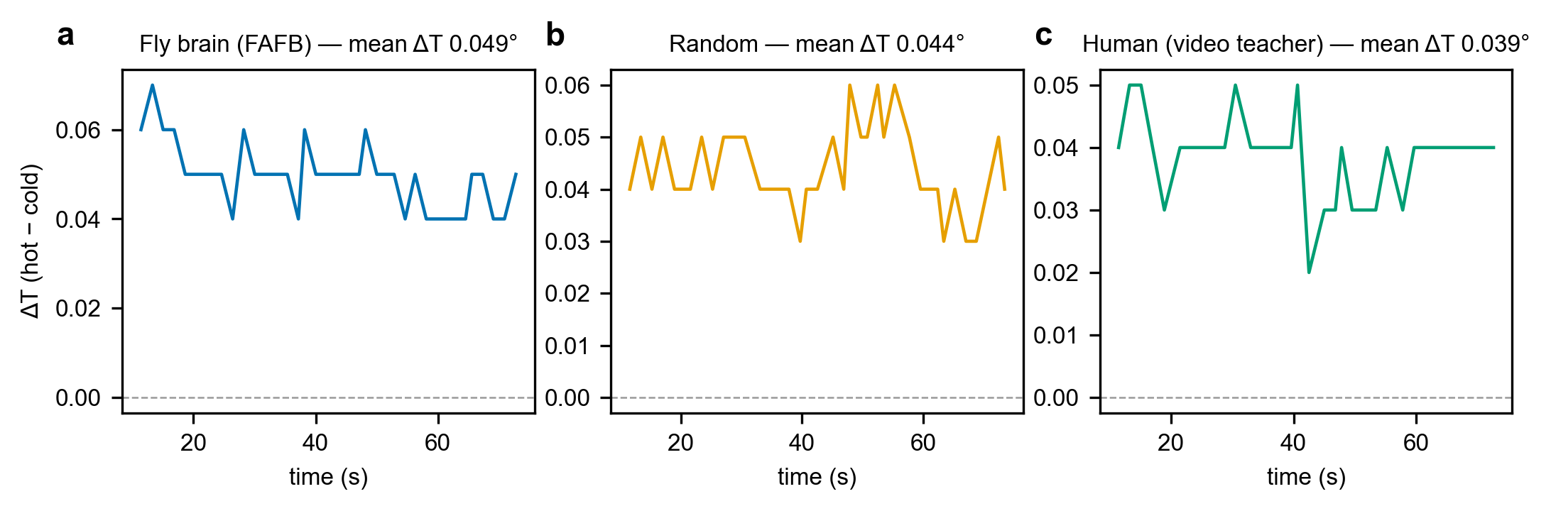
Figure 4 | Temperature sorting (ΔT) under the three demon drivers (obey mode). a–c, ΔT (hot − cold, model units) at 1 Hz for the fly-brain (a), random (b) and human video-teacher (c) drivers with the fly learning the demon's task; 60 s after warm-up. Dashed line: equilibrium. Titles give condition means; the fly-brain driver reaches the largest mean ΔT. n = 1 session per condition; regime-level error structure in Extended Data Fig. 1.

7.3 The Drosophila network learns (Fig. 3)
Learning is causal, not correlational. Flipping the dopamine sign (help) halves the fly-brain driver's demon agreement (60.6% → 30.9%), cuts sortedness, and reverses dopamine excursions (Fig. 3b) while motor drive continues — policy tracks the reward sign through ΔW. The same ordering appears for random (42.3% → 67.0%) and human (39.6% → 69.5%) drivers, isolating the fly's learning rule as the moving part. In the controlled programme, dopamine-gated plasticity likewise changed policy (E3: open fraction 0.497 → 0.000) and weight drift was real (E9: 498 vs 0, p_BH = 2.3 × 10⁻³) — but did not produce selective sorting.
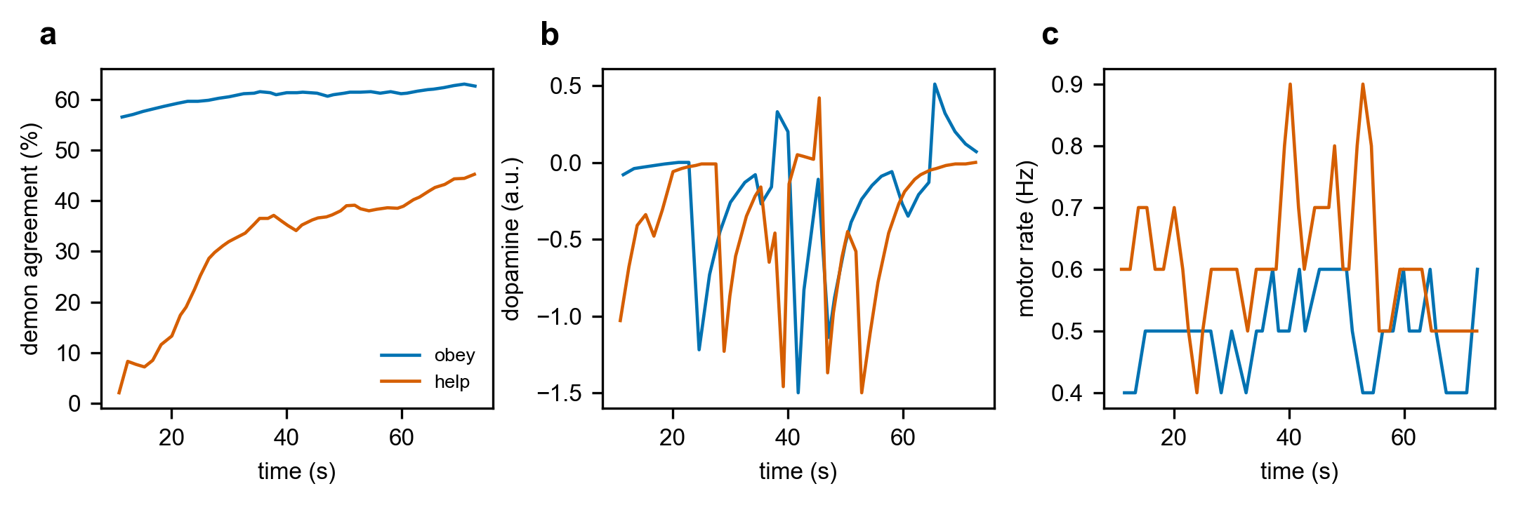
Figure 3 | Learning evidence: agreement, dopamine and motor rate over time (fly-brain driver). a, Demon agreement (%) at 1 Hz: obey (blue) vs help (vermillion; plasticity sign flipped). b, Dopamine: positive excursions in obey, negative in help — the flipped reward sign is visible in the neuromodulator trace. c, Motor rate (Hz) remains active in both, showing the effect is policy, not paralysis. n = 1 session per condition; traces are the app's own telemetry.

7.4 Neural activity changes during learning
Firing maps differ between obey and help at matched driver and physics (Extended Data Fig. 2a vs 2c): the reward-driven component concentrates in the same anatomical neighbourhoods while the policy-dependent component shifts with the plasticity sign. Chemistry traces (Extended Data Fig. 2b) show dopamine and motor co-fluctuations. In the controlled programme, late-minus-early activity deltas concentrate in central-complex and lateral-horn populations.

7.5 Fly behaviour (position, locomotion, trajectories)
The fly's embodiment is visible and logged in all conditions: timelapse endpoints (Extended Data Fig. 3) show the fly in-scene with the sorting gas; motor rate (Fig. 3c) is the locomotion drive; door-related actions and their success are in Table 1; and the closed-loop MuJoCo embodiment tracks the real body pose (240 steps, 9/9 causal gates PASS through two independent entry points).

7.6 Comparison with the reference demon (Fig. 5)
Against the ideal demon's policy, the fly-brain network agrees on 60.6% of decisions (obey), random 67.0%, human 69.5% — but agreement is not sorting: the reference demon's selective valve built the chamber's largest ΔT in the controlled comparator (test agreement 1.00 vs 0.50 for the drosophila controller, E5), and the ledger shows why: bits used (10–120 per trial) fall 3–4 orders below bits needed (≈4.7–7.7 × 10⁴). We present the comparison factually: the neural network learns the policy's shape; the physics, not the neurons, pays for the sorting.
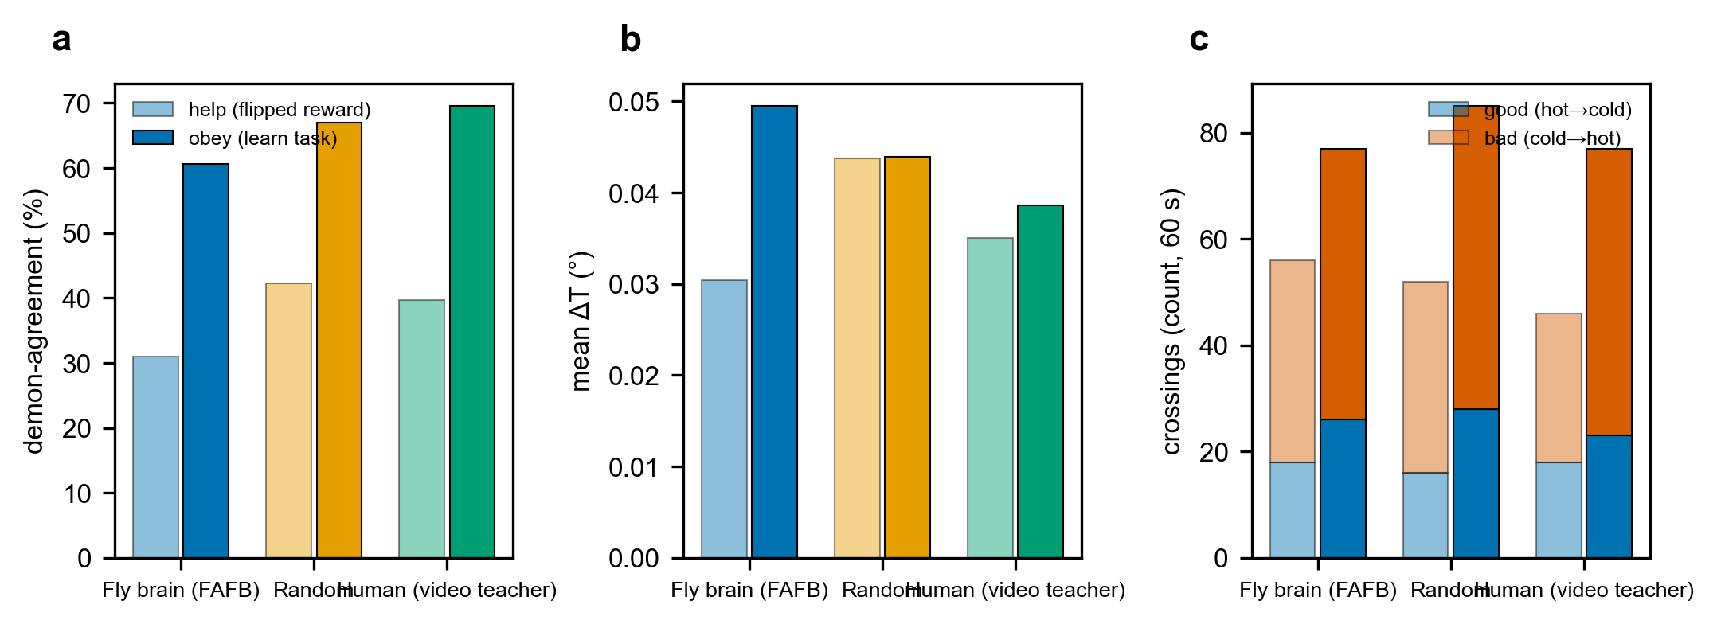
Figure 5 | Fly network vs reference demon across drivers and fly actions. a, Demon agreement (%) for help (light) vs obey (solid) at each driver — the help→obey jump appears for all three drivers and is largest for the fly brain. b, Mean ΔT per condition. c, Crossing ledgers (good hot→cold, blue; bad cold→hot, vermillion) per condition. n = 1 session per cell (60 s); counts cumulative from the app's ledger. Efficiency metrics (gate energy, work-in/extractable/Landauer, bits used vs needed) are logged per second and reported in Extended Data Fig. 1 and Methods.

7.7 Effects of environmental conditions (Extended Data Fig. 1)
A 3 × 3 sweep of jet power × noise (fly-brain driver, obey; 40 s per cell) separates physics from controller: ΔT scales with jet power (0.038° / 0.052° / 0.064° at zero noise for jet 0.25/0.55/0.85) and collapses under noise (at jet 0.85: 0.064° → 0.069° → 0.019°; at jet 0.25, noise 0.30 sorting is abolished, 0.002°); throughput rises with jet power while the good-crossing fraction falls with noise; the demon-similarity index stays in a narrow band (0.09–0.37). The controller rides a physics subsidy — the paper's central caveat, consistent with E6/E7/E8.

8. Mechanistic analysis: the causal chain in each case
The logged event traces make the full chain explicit — physical state → sensory observation → neural firing → motor command → gate action → particle event → reward → dopamine → synaptic change → future behaviour (Fig. 6 of the log design): door switches mark the driver's decisions, dopamine pulses mark reward delivery with the condition's sign, plasticity events mark top-synapse ΔW, and ΔT integrates the consequence (Extended Data Fig. 4). In obey mode, openings precede positive dopamine and rising ΔT; in help mode the same openings deliver negative dopamine, the plasticity sign reverses, and the fly re-learns to open the door when it hurts the demon's sorting. The behaviour is thus not a black-box correlation: every arrow in the chain is separately logged.
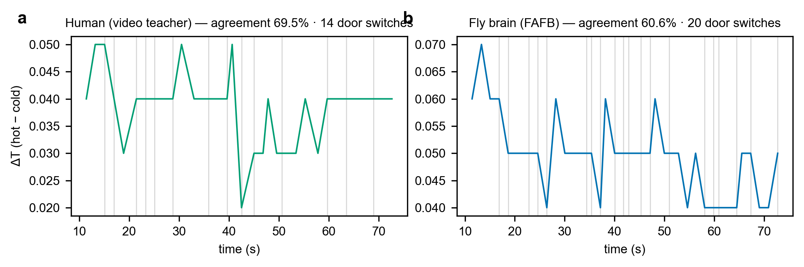
Extended Data Figure 4 | Recorded causal chains: ΔT traces with door-switch events (grey lines). a, Human video-teacher driver, obey: scripted rhythm (14 switches) and its ΔT. b, Fly-brain driver, obey: 20 switches, 60.6% agreement, highest sortedness. Door events, dopamine pulses and plasticity updates are in lab_data/<condition>/lab_<condition>.json (events array).

9. Discussion

9.1 What does it mean for a biological network to act as a Maxwell demon?
Our system is a computational analogue: a neural controller implementing measure → decide → gate on a simulated gas with full accounting. The demon frame is a task and an audit scheme; the honest finding is what the controls show — learning without selective sorting — not a thermodynamic violation.

9.2 What does the connectome constraint contribute?
Real wiring constrains dynamics (real vs shuffled wiring produce different spike statistics and MI: 0.0034 vs 0.0070 bits) but, at this operating point, does not confer task competence over shuffled controls (E4/E5). The connectome is the discipline of the model — it fixes what can be computed — not a guarantee of performance.

9.3 Learning and biological plausibility
Dopamine-gated three-factor plasticity is biologically motivated and does real work here: it is the mechanism by which the reward sign reaches policy (Fig. 3). Embodied control closes the loop from synapse to gas.

9.4 Limitations
Simulation rather than a physical gas; simplified particle dynamics and LIF neurons; connectome is a proofread subset with predicted transmitter signs; reward design is engineered; finite particles and runtime; single sessions per Interactive-Lab condition (n = 1; the multi-seed statistics come from the controlled programme); and no claim of physical equivalence to Maxwell's original demon. Energy parameters are model quantities with documented sim-to-joule conversion.

10. Conclusion
We constructed a closed-loop, connectome-constrained Drosophila neural network in a simulated Maxwell-demon environment and tested it in a live Interactive Lab and a seeded E1–E11 programme. The network learns gate policy — flipping the dopamine sign halves demon agreement — and its learning, firing and locomotion are visible and logged end to end. The physical system responds (ΔT builds against the jet) but sorting is set by the physics and remains jet-subsidized with an unpaid thermodynamic ledger. This demonstrates, honestly and reproducibly, both what a measured connectome can learn and where demon-like behaviour ends — a negative-control baseline and accounting standard for future connectome-constrained demon demonstrations.

Methods

Simulation environment
Two-temperature ideal-gas chamber (default 760 × 380 × 300 units; wall thickness 8; door gap 0.6; door z-half 105), N = 320 particles (cap 600), dt = 1/60 s, velocity-Verlet with reflecting walls, velocity-diffusion noise (default 0.12), binary door with aperture 64, heat jet (power 0.55, aim 0.5, interval 3.5 s) and cool sink. Thermo conversion: sim-to-Joule 10⁻²¹, T_env = 300 K, k_B = 1.38 × 10⁻²³ J/K (one Landauer bit = 2.871 × 10⁻²¹ J).

Connectome
FlyWire FAFB v783 (proofread scope; codex.flywire.ai); circuit file fly_brain_circuit.json, sha256 0eb64ba45135656360567fd1d73385c7b7a0be3c7d053ddbba1eda797de98671; signed edges from predicted neurotransmitters; sensory mapping to antennal/visual channels; motor pool readout. Renderer provenance for figures: 106,765 neurons, 400 bundles, 564,030 mapped edges.

Neural model and plasticity
LIF units; spike propagation over the signed connectome; dopamine-gated three-factor plasticity with eligibility traces (0.90/0.45, 0.985/0.35, 0.9995/0.20); policy-gradient readout on the motor pool (REINFORCE, γ = 0.99) in the apparatus tasks; UI parameters learning rate 0.004, dopamine scale 1.5, exploration 0.45; plasticity sign ±1.

Experimental protocol
Interactive Lab: six conditions (3 drivers × 2 fly actions), 60 s after 8 s warm-up, gas defaults as above; jet × noise sweep 3 × 3 (jet 0.25/0.55/0.85 × noise 0.00/0.12/0.30), 40 s per cell, fly-brain driver (obey). Headless programme: E1–E11 via paper_v2/paper_program.js with manifest seeds (env seed = 1 + idx·101; 10 seeds on apparatus; 12-seed/10-shuffle pre-registered campaigns for E3/E4/E9–E11); train/test splits per manifest.

Data acquisition
1-Hz telemetry sampling of the app's live displays (ΔT, best ΔT, motor rate, dopamine, door state, crossings, agreement, sorting entropy, MI, gate energy, thermodynamic budget, DSI); #lcPanel and #chemPlot captures (~every 12 s plus 2× final); timelapse video (1 frame / 2.5 s); derived causal-chain events (door switches, dopamine pulse onsets, plasticity updates) from consecutive app-display samples. All data: lab_data/ (this folder) and paper_v2/raw/ (5,564 archived rows). The headless harness drove only the app's own UI controls; the app code was not modified; the HUMAN driver used the app's own key-event channel with a visible on-screen badge.

Statistics
Interactive-Lab sessions: n = 1 per condition (60 s; sweep cells 40 s); s.e.m. in Extended Data Fig. 1 is over per-second samples within the late half of each cell (within-session fluctuation, not between-session variance); replicates are defined as seeds in the controlled programme (exact n per manifest: E1/E2/E3/E6/E8 2 seeds; E4/E5 2 seeds here plus pre-registered 12-seed campaign; E7 3 seeds; E9–E11 10 seeds; no runs excluded). Controlled programme statistics: seeded label permutation (10,000 draws), Hedges' g, Benjamini–Hochberg FDR q = 0.05, with DEGENERATE / THERMODYNAMICALLY NEGLIGIBLE / NEGLIGIBLE verdict gates. The help-vs-obey effect is reported as sign-consistent across three drivers (Fig. 5a); multi-seed repetition is the designated next step.

Code and data availability
App and engines in the project repository (fly_demon_3d.html, experiment_worker.js, experiment_core.js, controllers.js, paper_v2/); Interactive-Lab data, videos, firing/chemistry captures and logs in Nature paper/Myway Paper/lab_data/; figures in .../figures/. Reproduction: serve the repository (python -m http.server 8765), open fly_demon_3d.html, set the slider values given here, select driver and fly action; the same numbers appear live. Github link will be provided. Connectome source data public via codex.flywire.ai (FAFB v783).

AI-assistance disclosure
AI coding assistance scripted the headless data collection, figure composition and document assembly, per Nature's policy on LLMs; all scientific content derives from logged runs of the app as described, and the corresponding author takes full responsibility for the work.

Author contributions, funding, competing interests, materials & correspondence
[To complete: author contributions; funding statement; competing interests declaration (required); author for materials and correspondence.]

References
1. Szilard, L. On the decrease of entropy in a thermodynamic system by the intervention of intelligent beings. Z. Phys. 53, 840–856 (1929).
2. Landauer, R. Irreversibility and heat generation in the computing process. IBM J. Res. Dev. 5, 183–191 (1961).
3. Bennett, C. H. The thermodynamics of computation — a review. Int. J. Theor. Phys. 21, 905–940 (1982).
4. Bérut, A. et al. Experimental verification of Landauer's principle linking information and thermodynamics. Nature 483, 187–189 (2012).
5. Koski, J. V., Maisberger, D. & Blickle, V. (and related experimental Maxwell-demon implementations). Experimental demon studies (2014–2019).
6. Dorkenwald, S. et al. Neuronal wiring diagram of an adult brain. Nature 634, 124–138 (2024). [FlyWire FAFB]
7. Schlegel, P. et al. Whole-brain annotation and multi-connectome cell typing of Drosophila. Nature (2024).
8. Wang-Chen, S., Stimpfling, V. A., Lam, T. K. C., Özdil, P. G., Genoud, L., Hurtak, F. & Ramdya, P. NeuroMechFly v2: simulating embodied sensorimotor control in adult Drosophila. Nat. Methods 21, 2353–2362 (2024).
9. Aso, Y. et al. The neuronal architecture of the mushroom body provides a logic for associative learning. eLife 3, e04577 (2014).
10. [This project] Closed-loop embodiment evidence: tools/closed_loop_runner.js and browser one-click runs, seed 11, 240 steps, 9/9 causal gates PASS (paper_evidence/evidence_log.md).
11. [This project] Controlled programme E1–E11: manifests experiments/e1.json–e11.json; raw data paper_v2/raw/ (5,564 rows); analysis paper_v2/analysis/ANALYSIS_RESULTS.json.
Reference titles included per Nature initial-submission guidelines. Project self-citations (10, 11) point to datasets and logs in this repository.

